

**SERVICE LEARNING PROJECT REPORT**

**NGO:** AKSHAAR PAUL

**STUDENTS ATTENDANCE MANAGEMENT SYSTEM WITH POWERBI REPORT GENERATION**

**DIGITIZATION OF PHYSICAL STUDENT RECORDS**

**SUBMITTED BY**

GROUP **8**

ABHISHEK RAJPUT 22070122007

ARMAAN JESWANI 22070122029

GAURI DEOGHARE 22070122049

MALAY DOSHI 22070122059

**UNDER THE GUIDANCE OF**

**FACULTY MEMBER:**

Dr. Dipti Theng

Assistant Professor

**EXTERNAL MENTOR:**

Mr.Nagesh Alkunte

Mr.Shivam Kolhe

**Department of Computer Science and Engineering**

**SYMBIOSIS INSTITUTE OF TECHNOLOGY, PUNE**

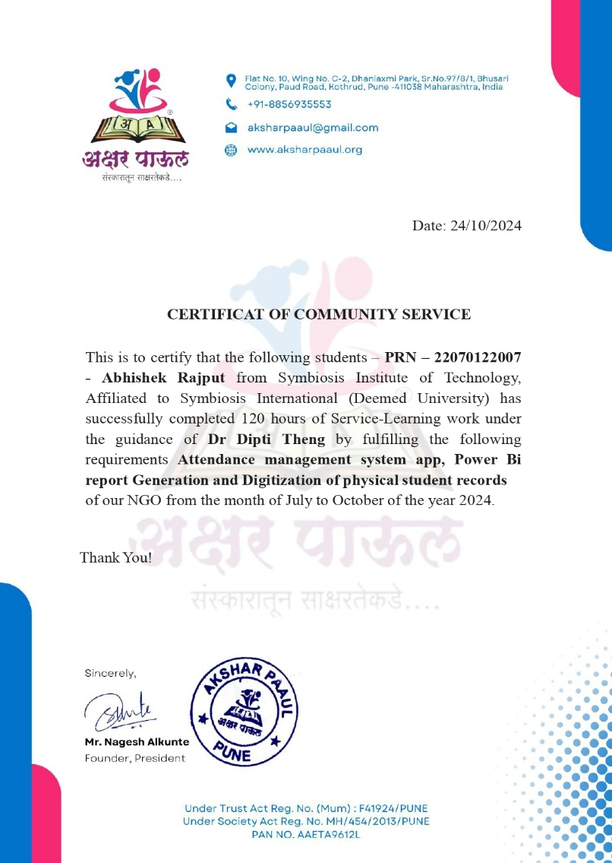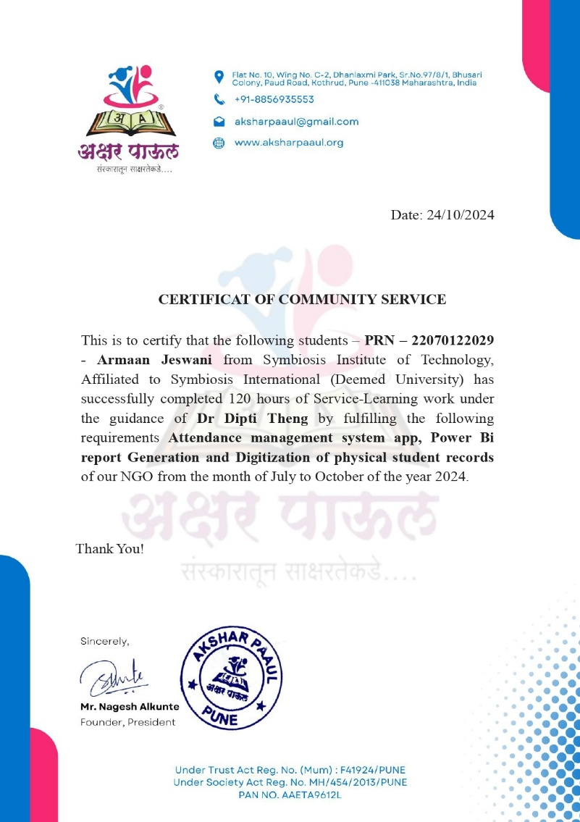

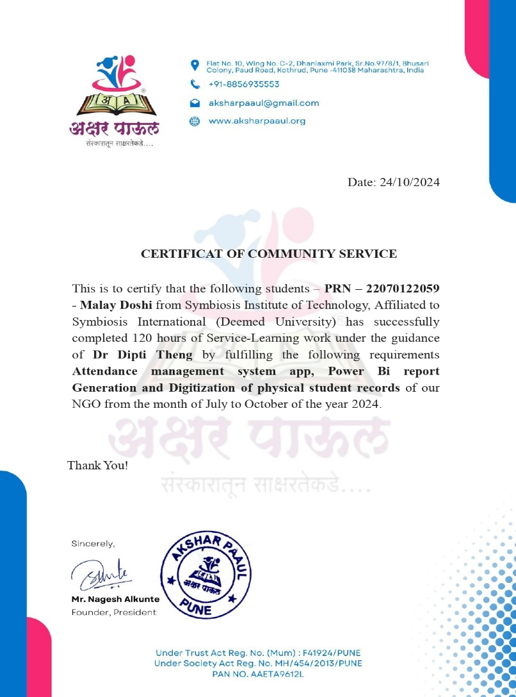

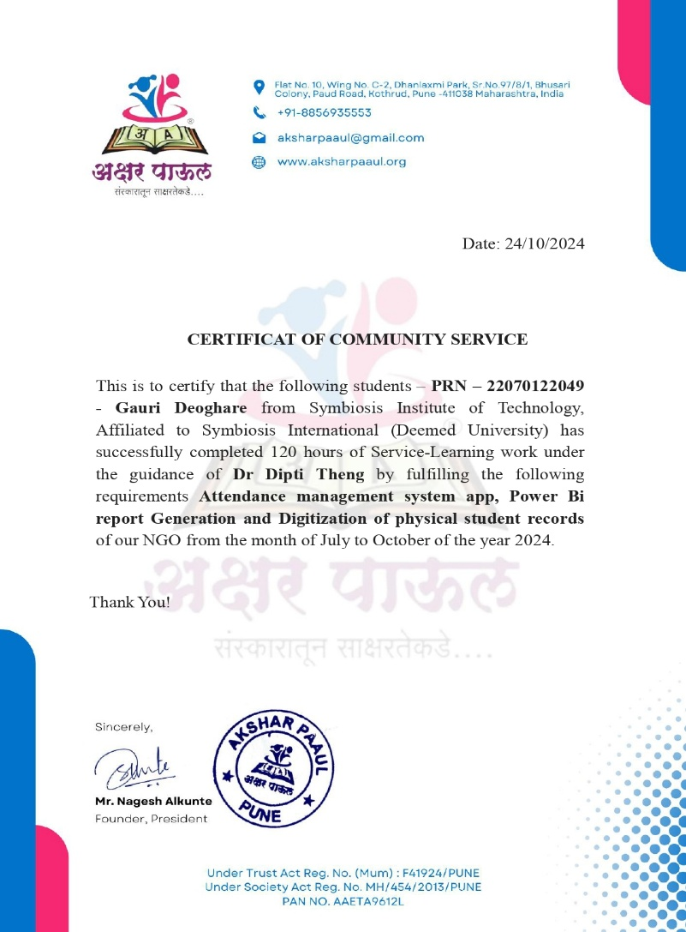

**ACKNOWLEDGEMENTS**

We thank **Symbiosis International University** for arranging this Service Learning opportunity, and incorporating dedicated hours for it.

We thank **Akshaar Paul** for providing an opportunity to work on a project of great significance to the core management of the organization.

We are grateful to our Faculty Mentor, **Dr. Dipti Theng**, and External Mentor, **Mr. Shivam Kolhe** and **Nagesh Alkunte** for extending patient guidance, advice, and opportunities to improve upon our work.

We also express our sincerest thanks to our classmates and faculty members whose cooperation made this Service Learning project very fruitful, enjoyable, and memorable.

**TABLE OF CONTENTS**

1. Certificate of Completion2
2. Acknowledgements3
3. Table of Contents4
4. Introduction5
5. Problem Statement7
6. Project Planning8

6.1 Project Timeline8

6.2 SDLC8

1. Data Collection and Standardization11
2. Project Design15
   1. Work Flow Diagram 15
   2. Class Diagram15
   3. Use Case Diagram16
   4. Figma Design17
3. Implementation19
4. Deployment and Testing24
5. NGO Images26
6. Final Application29
7. Conclusion31

**4. INTRODUCTION**

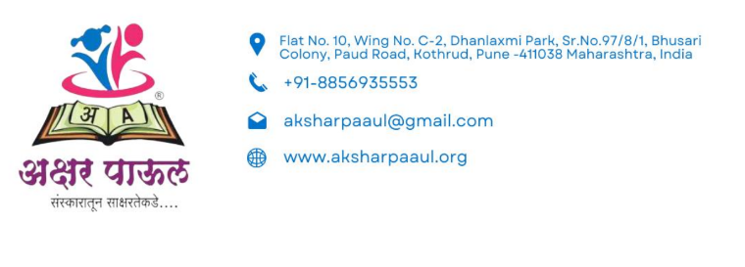

Akshar Paul NGO is committed to improving literacy and providing support to underprivileged children. The organization was established way back in 2013 in Pune. The organization has expanded the service into Nashik and Satara and is further looking at reaching out to more needy children in these regions in terms of education access.

Akshar Paul has been working with pavement dwellers and construction-site-based families who do not receive formal education due to their nomadic lifestyles and have no other material backup. Most of them don't have books and other reading materials, making it difficult for them to keep up with their peers in more stable environments.

To overcome all these obstacles, Akshar Paul offers free educative programmes to remote communities. They provide educational services to include basic education and numerical classes along with books and learning aids, and additional support to help children stay engaged and motivated in their studies. By creating a supportive and nurturing learning environment, Akshar Paul aims to give these children the tools they need to build a brighter future.

**PROBLEM FACED BY THE NGO**

Akshaar Paul has brought about one of the more significant challenges in the NGO mission of Akshar Paul, which provides for quality education to these economically deprived children, mainly living on pavements who can hardly be found sitting around a single place but at sites of construction. Since many of these children lack the privilege of continuous schooling because there is no stability either at the workplace or in houses.

Another major hindrance lies in managing the books for different libraries scattered around places because most children read off copies of learning resources developed by the organization; an effective library resource management tool will help keep track of the number of copies, hence determining which book should be brought back by a child. It is very challenging however to maintain an organized inventory without a formalized system. Books and other learning resources are frequently lost or not returned. Lack of structures in managing the inventories of the library can lead to resource shortages, making it unbearable to steadily meet the demand for education placed upon the children regularly.

A simple matter of attendance management on behalf of Akshar Paul NGO is that in general, the process would even be more hectic to get the attendance as being marked physically. Teachers along with administrators are highly affected to ensure that all the attendance recordings of the children at diverse scattered and mobile locations serviced in the communities are physically written down. This manual process is time-consuming, labour intensive, and prone to possible errors, especially when having to monitor children who can miss school at any particular time. In addition, this kind of community often does not have stable facilities, and the task of carrying physical books around becomes cumbersome and inconvenient.

Teachers and administrators cannot effectively keep track of records and data because the children also miss school irregularly. In such cases, it becomes difficult to fill gaps about attendance records and, therefore, challenges the fulfilment of adequate support for each child. Further, retrieval of historical data for the assessment of a child's progress or identification of those who need more attention due to low attendance proves difficult without digital or automated systems. The manual process also complicates the consolidation of data and its analysis, which are critical for tracing the impact of the program and making improvements.

**5. PROBLEM STATEMENT**

1. Attendance is recorded manually, a process that is often prone to errors and inefficiencies. The NGO struggles with manually tracking student attendance, leading to inaccuracies. This is time-consuming and labour intensive, diverting resources away from core educational activities.

2. Additionally, the student records from the past 10 years have been manually recorded in registers, which are both difficult to maintain and vulnerable to damage. To address this, these records have been transferred to a more suitable Excel format for easier management and preservation.

**WORK ALLOTED**

* Develop an efficient and user-friendly attendance management system. New system should leverage biometric tracking technology to ensure precise and consistent tracking of student attendance.
* Simplify the process for both the students and teachers by integrating Power BI reports.
* Digitalize the offline records.
* Teach students at NGO about English and basics of Computer software and hardware.

**6. PROJECT PLANNING**

**6.1 PROJECT TIMELINE**

**6.2 SOFTWARE DEVELOPMENT LIFECYCLE**

SDLC will be employed for the design of Biometric Attendance Management System so that each phase in its journey would help evolve a solution that is worth and capable of being termed reliable with user-friendliness and quality. For the Biometric Attendance Management System developed in this report, SDLC stages undertaken would include:

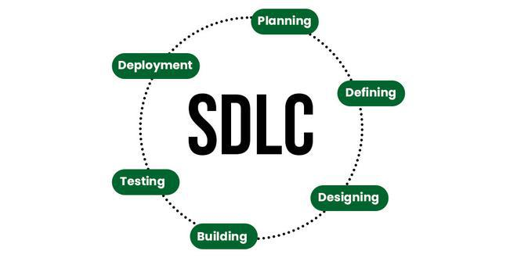

**Source:** [**geeksforgeeks.org**](https://www.geeksforgeeks.org/software-development-life-cycle-sdlc/)

**1.Requirement Gathering:** Communicated with the NGO (Akshaar Paul) in such a way that their requirements and pain points regarding attendance management and record-keeping could be understood. It thus helped in defining the goals of the project: digitization of records, a biometric attendance system, and reports through Power BI.

**2.Planning:** Define project planning with respect to timeline, deliverables, and major milestones so that timelines are defined for individual components like data collection, digitization, and software deployment. It also included resource planning and planning of tasks.

**3.Design:** We designed system architecture with database structure, a frontend interface and backend logic. We came up with use case, component, and deployment diagrams to visualize the general structure of the system and its workflow. We also prototyped the user interface using Figma to ensure it is usable and caters to the NGO requirements.

**4.Development:** The system includes front-end programming through HTML/CSS and back-end development using Python and Django, with a MySQL database for secure data storage. Key functionalities such as attendance reporting and data backup have been implemented to enhance efficiency and reliability. Additionally, Power BI integration allows for dynamic report generation, enabling administrators to visualize attendance trends, generate insights, and present data in an accessible, graphical format. All development was managed with version control through GitHub, supporting collaborative coding and continuous integration to ensure a smooth development process and effective team collaboration.

**5.Testing:** The system underwent thorough testing, checking for functionality, accuracy, and performance. Testing included unit testing, which looked at individual components, integration testing for any communication between modules, and a user acceptance test to make sure the system actually delivered what the NGO required.

**6.Deployment:** After the application tested positively, its deployment was made for on-site usage at Akshaar Paul. Training sessions were done and real-time data was fed into the system to make sure that the implementation of the software was as anticipated.

**7.Maintenance:** After the system is deployed, software upgrades, bug fixes, and performance monitoring are conducted regularly to keep the system efficient and reliable. Feedback will be collected regularly to look for areas of improvement that will make sure the system continues to meet the needs of the users.

**7. DATA COLLECTION AND STANDARDIZATION**

**1. ATTENDANCE DATA SOURCE:**

**Biometric Devices:** Attendance data is captured through biometric devices i.e fingerprint scanners.

**Data Gathering**: Biometric records were used to collect attendance data for a particular date which consists of various fields to record the attendance details of each student. The main pieces of information gathered are:

* Student Name - The student's given name.
* Student ID (Roll Number) – Distinctive identifier assigned to every student.
* Date - The recorded date of attendance.
* Presence status - Shows if the student was present or absent.
* Intime refers to the moment when the student arrived and checked in.
* Out time refers to the moment when the student officially leaves.

Every record reflects a student's presence on a specific day, providing a detailed overview of daily attendance, arrival, and departure times.

**Standardizing** data was done to ensure consistency and make it easier for data processing by following a set standard.

* Date Format - All dates were documented in DD-MM-YYYY format for consistency and simplicity in filtering.
* Check-in and check-out times were converted to a 12-hour format with AM/PM notation to make it easier to understand the times.
* Consistent attendance status labels ("Present" or "Absent") were used to ensure clarity and streamline data analysis.
* Maintaining consistency in roll numbers was important, so student IDs were kept in numeric form to facilitate sorting and identification.
* Completeness of Fields - Each row in the dataset was verified for completeness, making sure there were no missing values in key columns like Date, Status, Intime, Out time.

This standardization guarantees the data is neat, organized, and prepared for additional processing, analysis, or reporting in the biometric attendance management system.

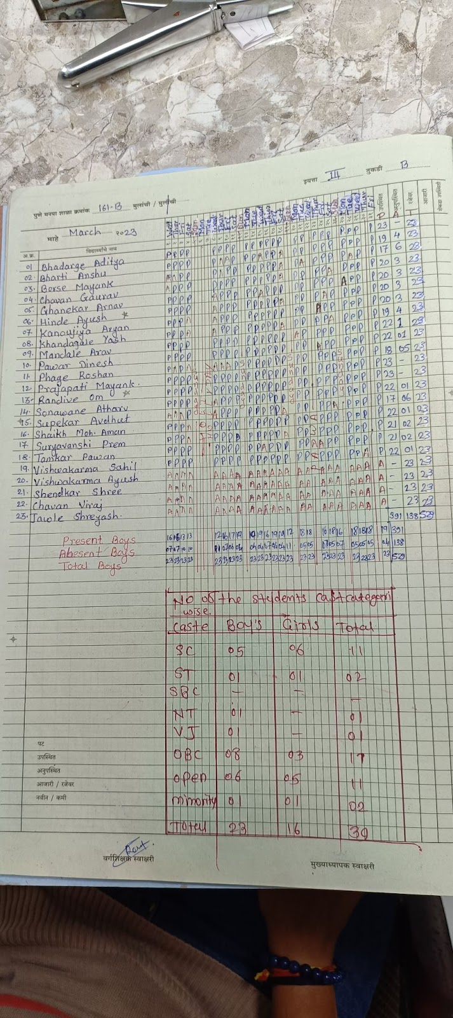

***Old Manual Attendance Record***

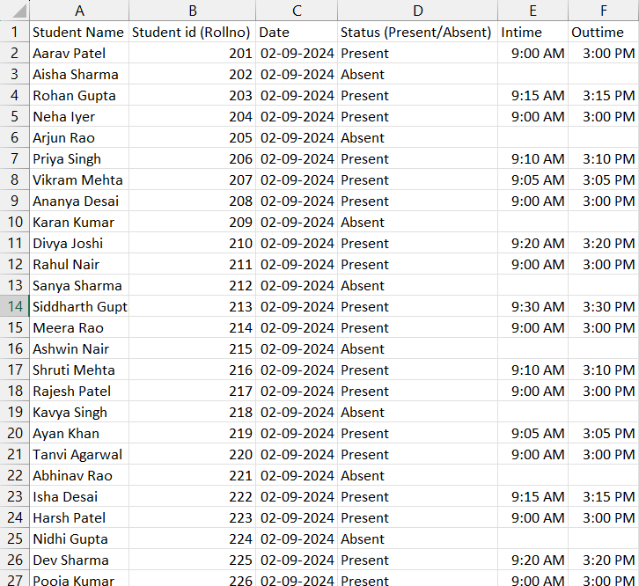

***Data Collection:*** *Biometric Device Attendance Data*

**Data Update Frequency:**

**Monthly Updates:** Attendance data from biometric devices will be synced and updated in the database monthly

After these steps, the data was ready to be deployed for the desktop application.

**2. STUDENT DATA SOURCE FOR DIGITIZE OF RECORDS:**

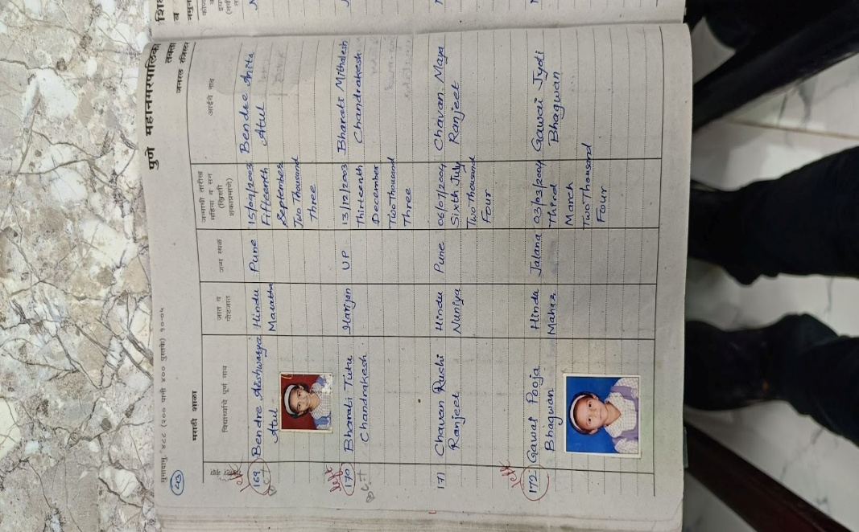

***Data Collection:*** *Physical Records*

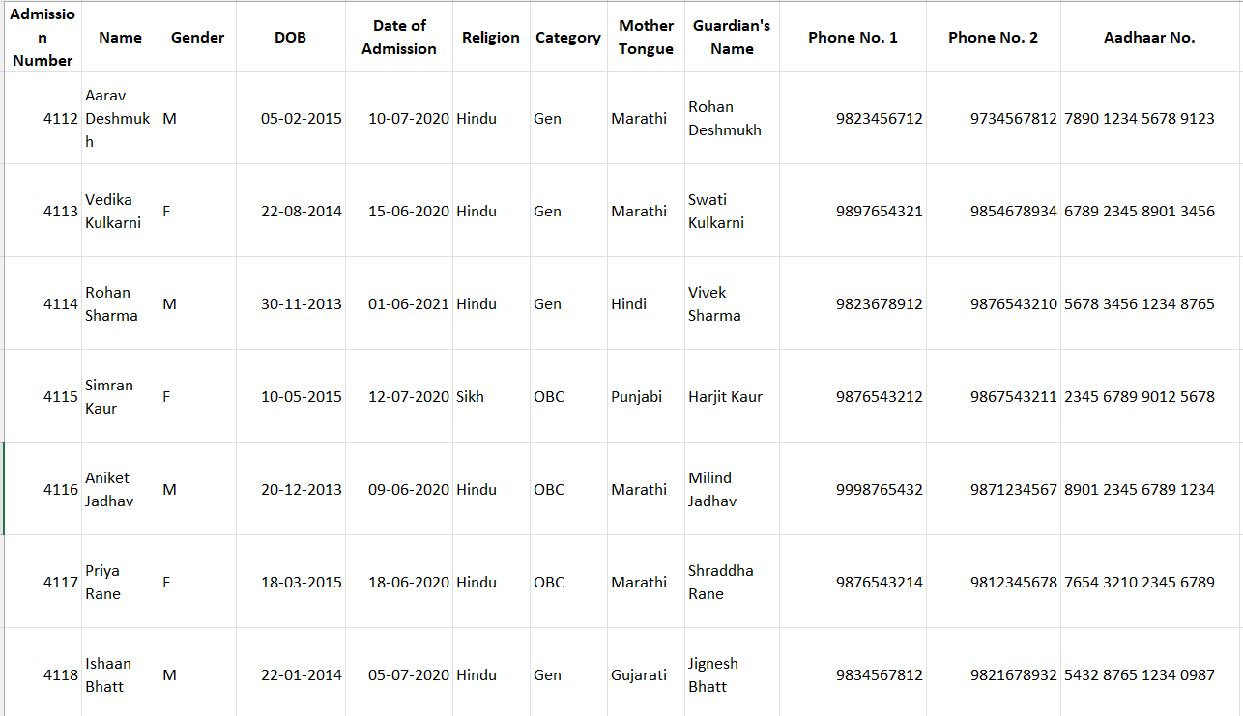

***Data Deployment:*** *Digitized Records*

**8. PROJECT DESIGN**

**8.1 WORK FLOW DIAGRAM**

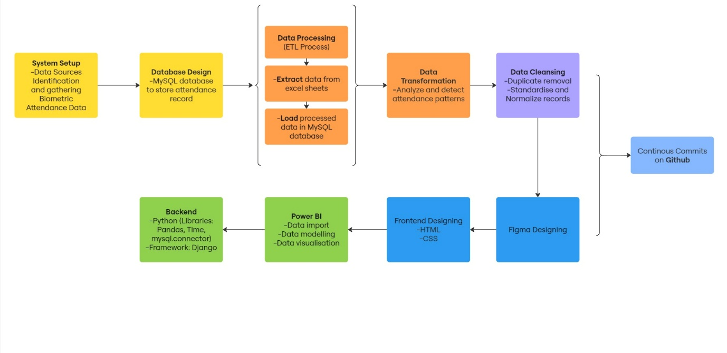

**8.2 CLASS DIAGRAM**

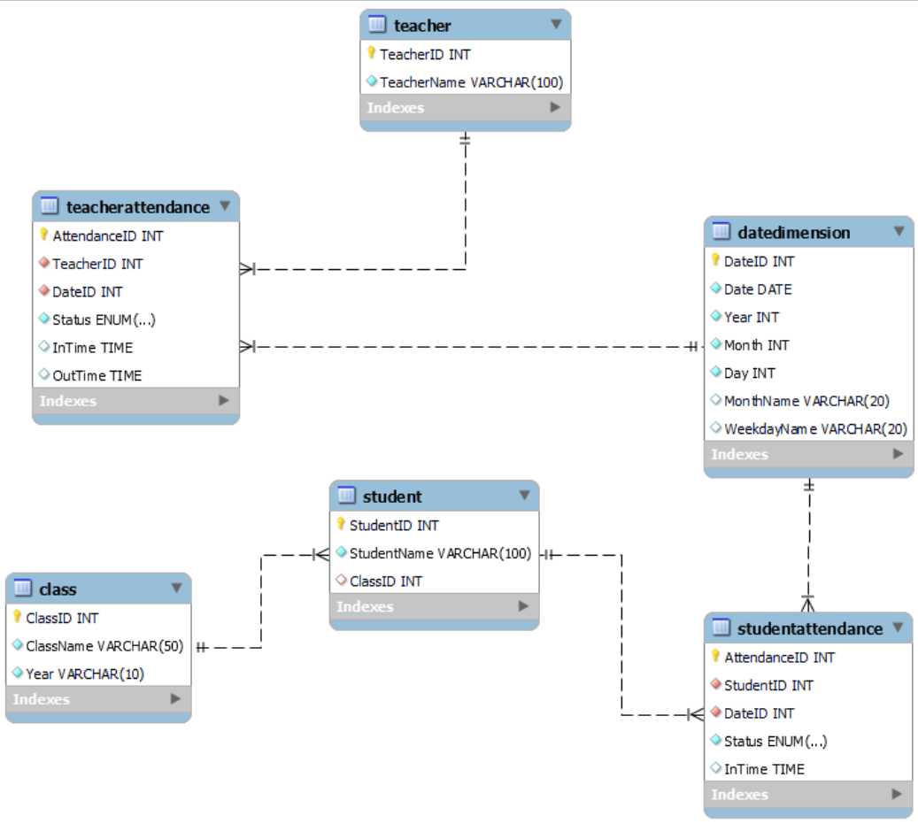

**8.3 USE CASE DIAGRAM**

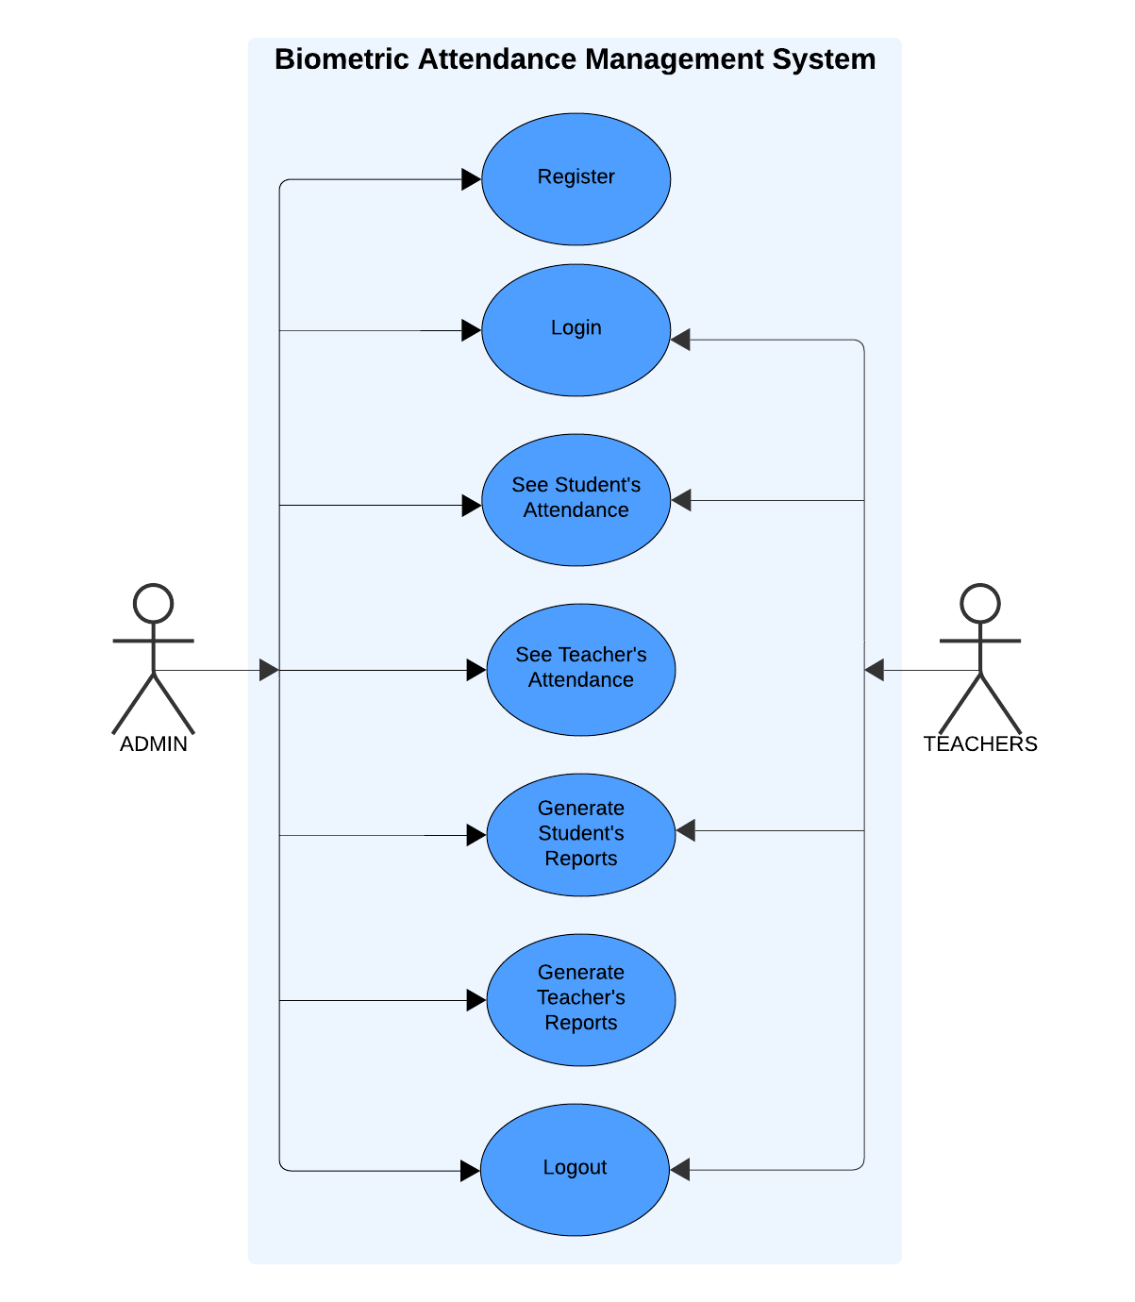

**8.4 FIGMA DESIGN**

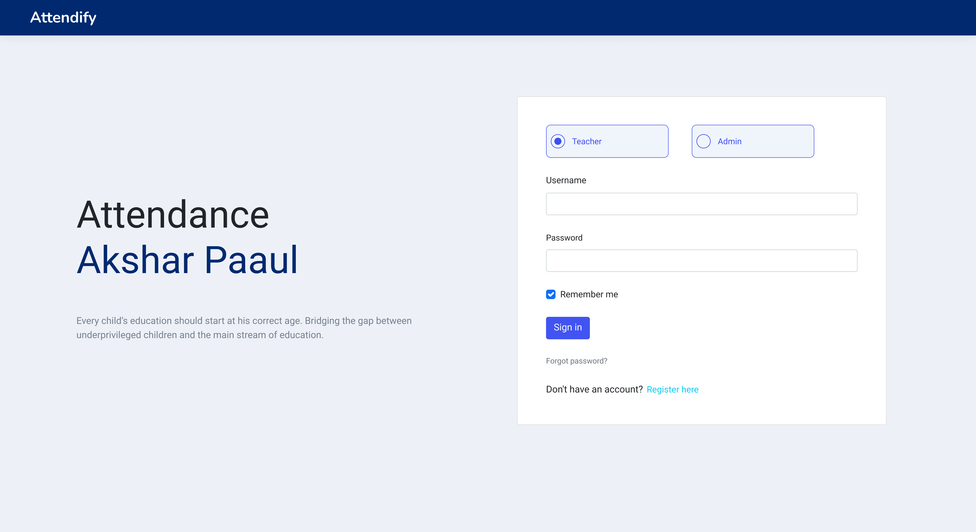

***Login Page***

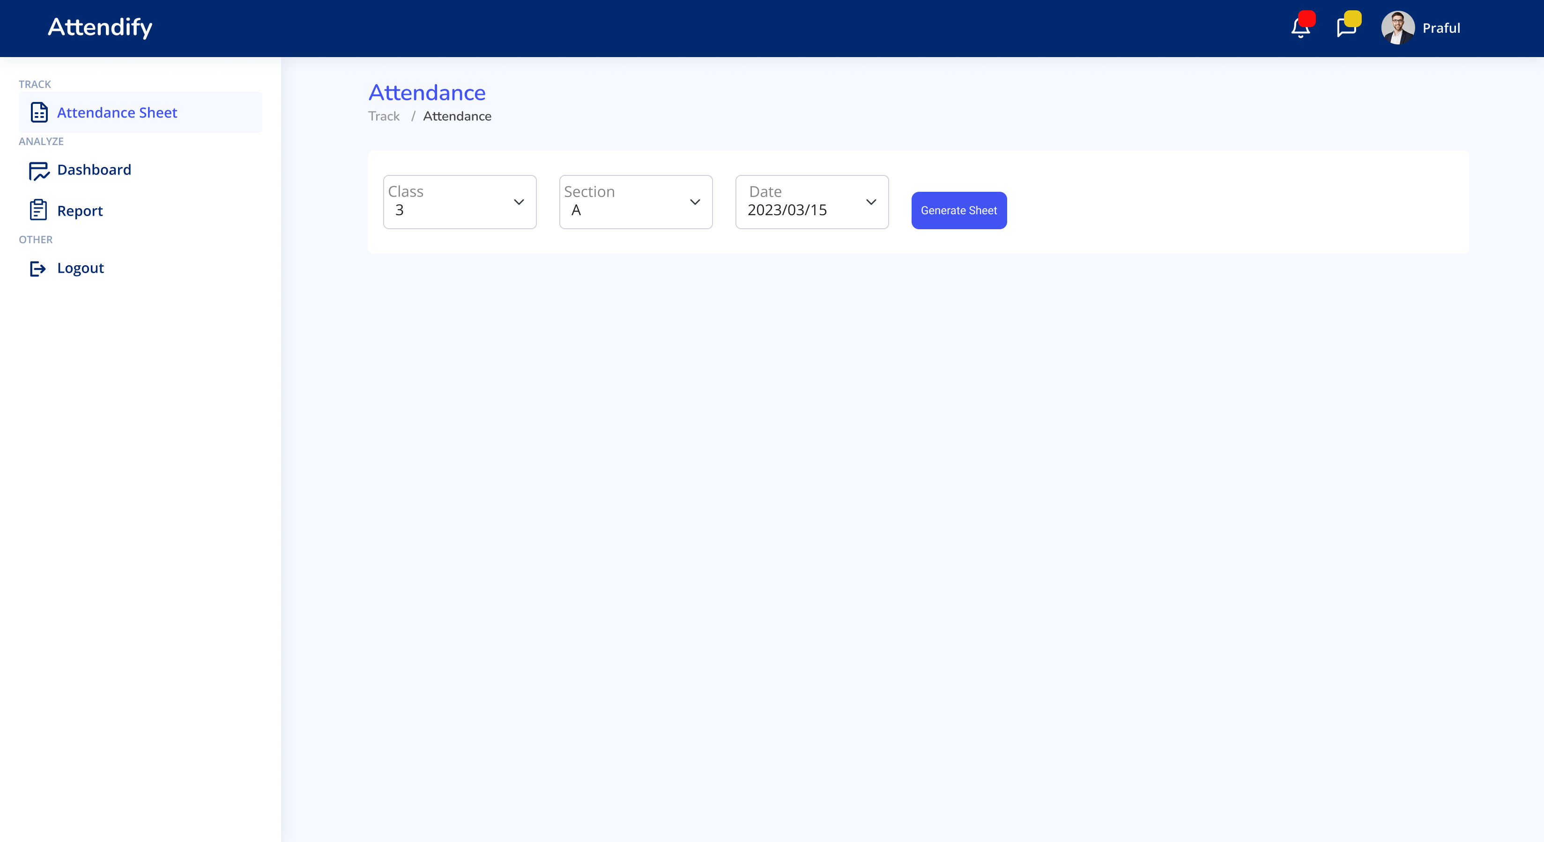

***Attendance Sheet Page***

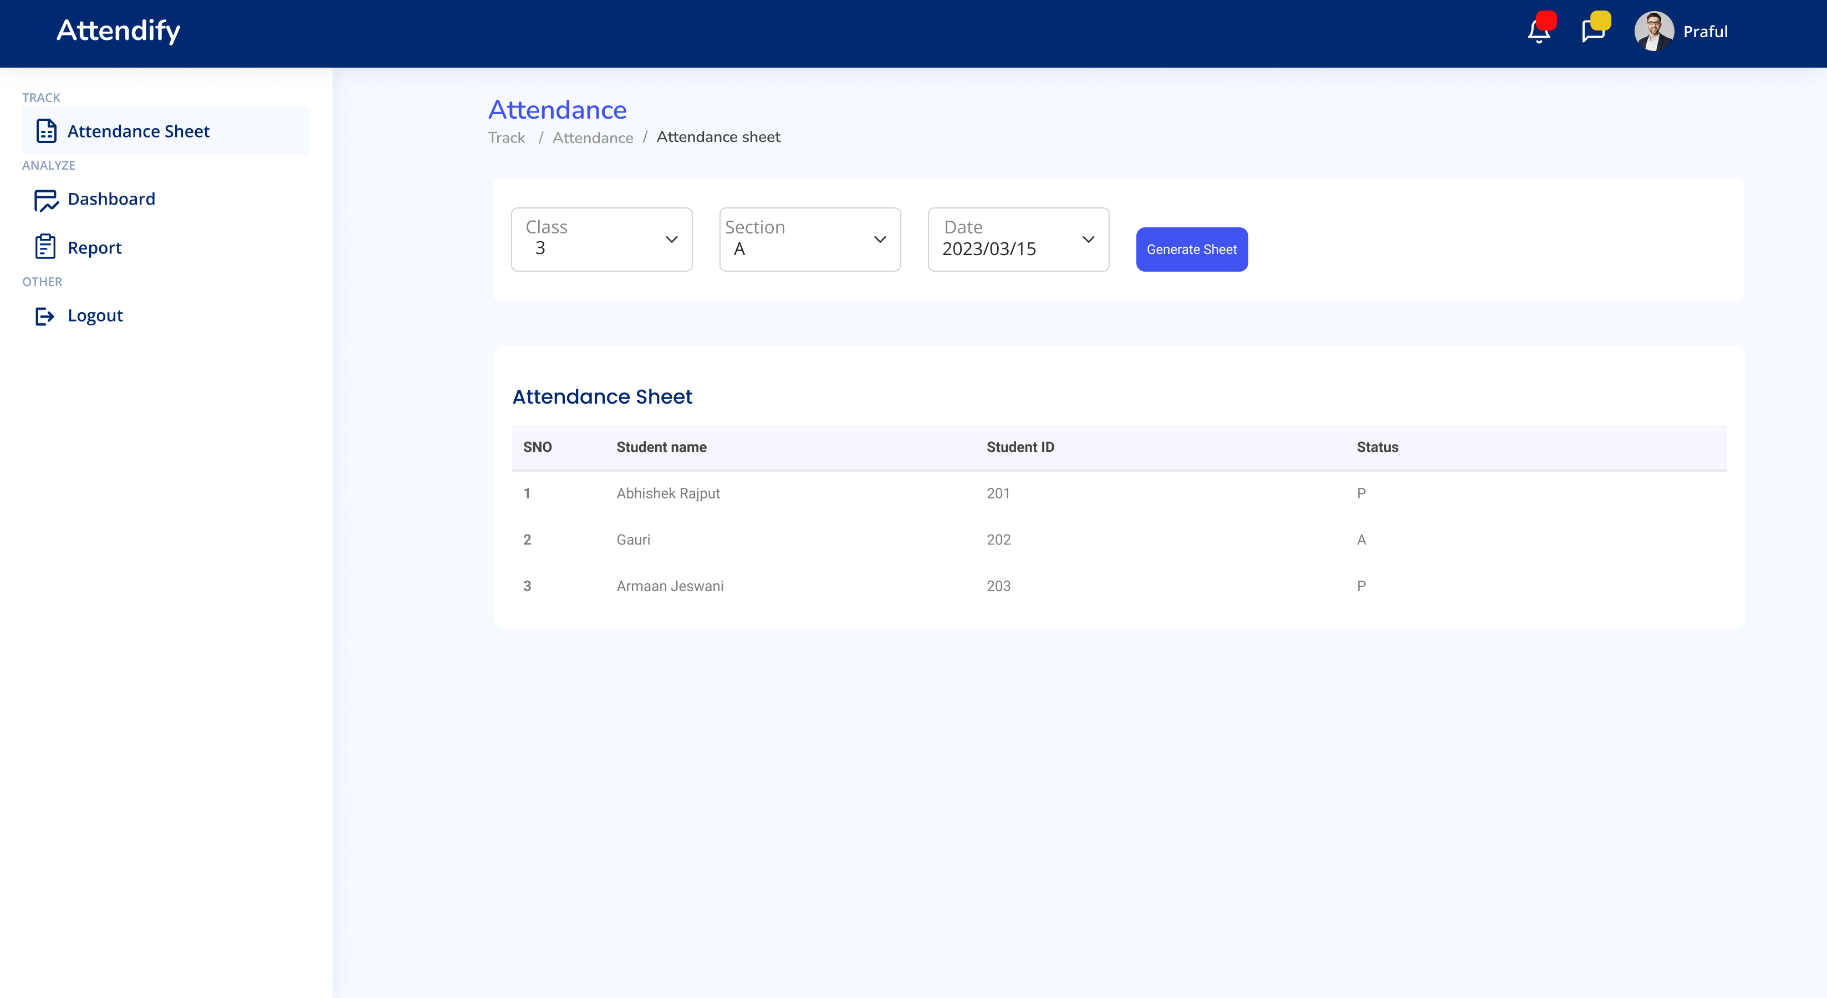

***Attendance Sheet Preview***

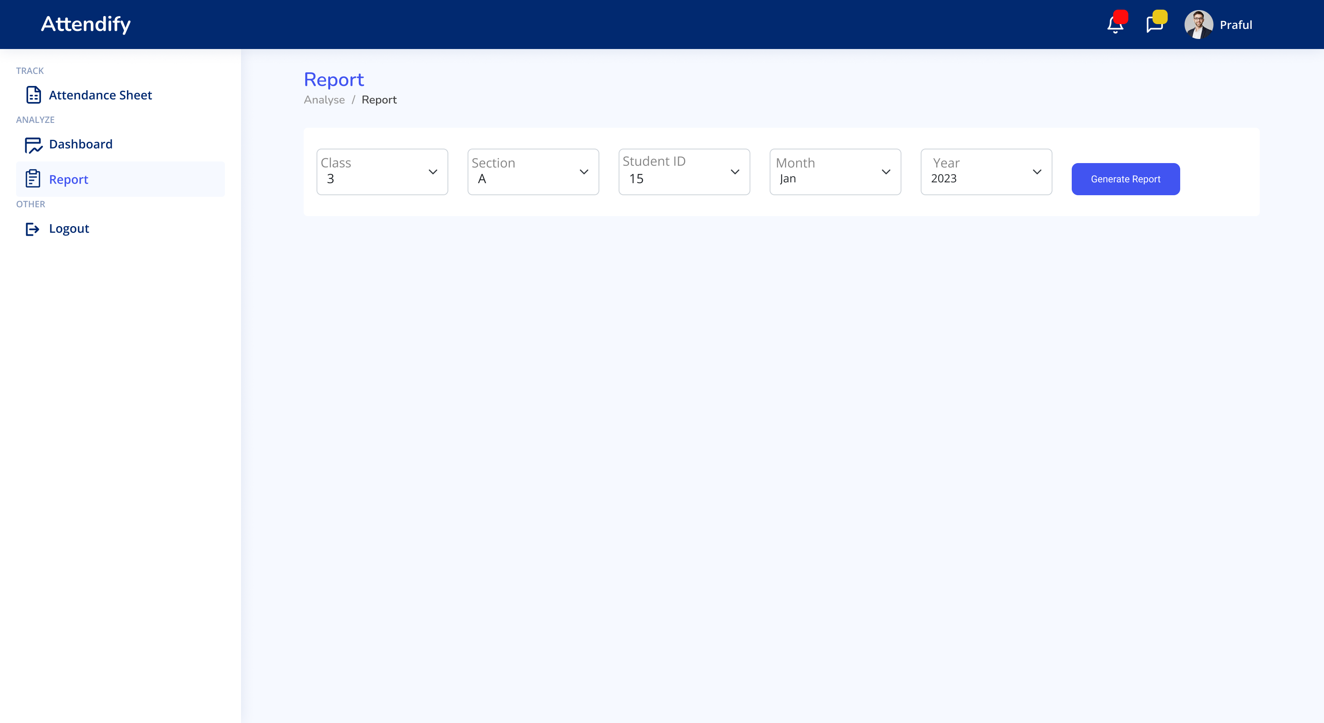

***Report Generation Page***

**Link:** [**Figma Link**](https://www.figma.com/design/x7W0kX0EWrjbKygvPwo8ev/Attendancne-management-system-(Community)?node-id=314-1339&t=wCCllhuwypP7CGYc-1)

**9. IMPLEMENTATION**

**DELIVERABLE SOFTWARE**

The deliverable software is a comprehensive Biometric Attendance Management System designed to streamline attendance tracking in educational institutions. Built with a focus on accuracy, ease of use, and robust data management, the software provides administrators with a reliable way to maintain attendance records through biometric data, reducing manual entry errors and improving record accuracy.

Also digitized manually entered 10 years old student data into the administrator system.

**TECHSTACK EMPLOYED**

**Designing:** Figma **Frontend:** HTML, CSS





**Database:** MySQL **Record Database:** Excel





**Backend:** Python,Django, Python Libraries (Pandas, Time, Mysql.Connector, etc)



**Report Generation:** PowerBI **Collaboration:** Git/Github





**Link:** [**Github Link**](https://github.com/Abhishek-2502/Attendance_Management_System_NGO)

The implementation of the Biometric Attendance Management System involved several key steps:

1. **System Setup**: Identified data sources and gathered biometric attendance data to establish a clear framework for data handling.
2. **Database Design (MySQL)**: Developed a MySQL database to securely store attendance records, user information, and biometric data, ensuring efficient data management.
3. **Data Processing (ETL Process)**: Conducted an ETL process to extract data from Excel sheets, transform it for analysis, and load it into the MySQL database.
4. **Data Cleansing**: Applied techniques to remove duplicates and standardize records, enhancing data accuracy and consistency.
5. **Backend Development**: Utilized Python and Django for backend development, leveraging libraries like Pandas and mysql.connector for data manipulation and database connectivity.
6. **Frontend Development**: Designed the user interface using HTML and CSS, guided by a Figma prototype to ensure an intuitive user experience.
7. **Data Visualization**: Integrated Power BI for visualizing attendance trends and summaries, providing insights through dynamic reports.
8. **Continuous Integration**: Maintained version control and collaboration using GitHub for continuous commits, ensuring updates were tracked and easily managed.

This structured approach led to a reliable and user-friendly system for managing biometric attendance effectively.

**A) FUNCTIONALITIES PROVIDED:**

The Figma design showcases the main functionalities of the Biometric Attendance Management System, which includes:

1. **Login Screen**: The initial interface allows users to log in securely with their credentials, ensuring that only authorized personnel access the system.
2. **Dashboard**: The dashboard provides an overview of key metrics, such as the number of present, absent, and total attendance records. It includes graphical data representation, allowing administrators to visualize attendance trends and gain quick insights.
3. **Attendance Management**: The attendance management screen enables users to view and manage attendance records for both teachers and students. Filters for date and user type help in narrowing down the records as needed.
4. **Report Generation**: This section allows users to generate attendance reports for specified time frames, making it easy to review attendance history and patterns.
5. **User Navigation**: A sidebar with navigation options such as "Dashboard," "Attendance Sheet," "Report," and "Logout" ensures easy access to various sections of the application, enhancing the user experience.

**B) Data - Management / Backup / Restore / Recovery / Export**

The Biometric Attendance Management System incorporates robust data management capabilities that guarantee the integrity, security, and accessibility of data. The following is a description of each function:

**Data Management:**

The database to be used in the system is a MySQL database where all data related to attendance records, biometric data, and user information will be stored. Good data management practices through indexing, normalization, and controlled access will enhance consistent, optimized, and secured data organization for performance and protection against unauthorized access.

**Data Backup:**

Regular automated backups are scheduled to prevent loss of data. Such automated backups will take a snapshot of the database that preserves both recent and historical records of attendance. These backup files are stored securely in such a manner that can be reverted when such recovery is required, thereby minimizing the disruption caused in case there is data corruption and accidental deletions.

**Data Restore**

The restore function allows administrators to roll back to the most recent backup in case data is lost or gets corrupted. It involves loading a previous copy of the backup into the database, allowing the system to revert to the stable state without some critical information that may have been lost.

**Data Recovery**

Recovery Mechanism: If the system happens to suffer an intractable loss of data or system failure, a recovery mechanism helps to bring back the system in a working state by the utilization of recently made backup. This reduces the time out with the operations with no permanent data loss during the failure.

**Export of Data:**

Administrators could also extract the attendance data into formats like Excel and CSV for reporting and analysis outside the system. This will enable users to provide attendance records for stakeholders, incorporate the data into other systems, or generate custom reports in making the data more accessible and usable.

**C) SYSTEM MAINTENANCE**

Regular optimization of the database, installation of updated software, and security patches required to guarantee that the Biometric Attendance Management System be running smoothly with data in a secured state. Regular backup testing saves the data from the loss, and system monitoring and performance tuning keep it from slowing down. The access of a user is reviewed regularly to maintain the secure access of data and log analysis helps in finding out the bugs arising in the system and fixes them too. Periodic interface improvements based on user feedback promote usability, as updated documentation ensures users are given accurate up-to-date guidance to specific functionality of the system. Together, these activities ensure the system remains reliable, efficient, and friendly over time.

1. **DEPLOYMENT AND TESTING**

**DEPLOYMENT**

The deployment of the biometric attendance management system will be undertaken by the NGO at a later phase, allowing them to implement it when they are fully prepared and have the necessary infrastructure in place. This phased approach enables the NGO to manage resources effectively, providing time for any additional staff training or adjustments required to ensure a smooth transition. By deploying at their preferred timeline, the NGO can also monitor and address real-time operational challenges, facilitating a gradual integration of the system into daily processes. Additionally, this strategy allows for initial feedback from users, which can guide further fine-tuning of the system to better meet their specific needs**.**

**TESTING**

**1. Unit Testing:**

* We verified each part of the system, including biometric data capturing, data entry forms, and database operations, to ensure they operated as anticipated.
* Every unit was checked to make sure it produced accurate results, performed well, and effectively managed errors to guarantee dependability.

**2. Integration Testing:**

* We evaluated how the front-end, back-end, and database components work together to guarantee smooth functioning.
* This stage allowed us to confirm the flow of data from capturing to storing and reporting, addressing any communication problems between components.

**3. Functional Testing**:

* Every system feature was evaluated based on the criteria to verify alignment with the intended functionality.
* Key aspects such as monitoring attendance, retrieving data, and generating reports were assessed to confirm their effectiveness.

**4. User Interface Testing:**

* We tested the user interface to ensure it met design and accessibility standards by checking usability, responsiveness, and compatibility across various devices.
* This testing validated the system's user-friendliness and intuitiveness.

**5. Performance Testing:**

* We assessed the system's ability to handle anticipated usage by measuring response times and load capacity.
* Through experimenting with bigger datasets, we verified that the system is able to handle high usage periods without any decrease in performance.

**6. Security Testing**:

* We carried out security assessments to detect and address any weaknesses, with a specific emphasis on safeguarding confidential biometric data.
* This involved examining access controls, encryption of data, and security protocols to protect data.

**7.User Acceptance Testing (UAT)**:

* We collaborated with NGO employees to evaluate the system in a practical environment, gathering input on usability and performance.
* Using the feedback provided, we made necessary final modifications to ensure the system better meets their individual requirements.

**8. Regression Testing:**

* Following every alteration or improvement, we conducted further tests on the system to confirm that there were no new problems created and to ensure that all features continued to function properly.
* Given the NGO's frequent updates and changes requested, this was particularly crucial.

**9. Final Testing and Documentation:**

* A thorough final testing phase was carried out to ensure all parts functioned together smoothly and met the project requirements.
* We recorded our testing outcomes, problems, and solutions in order to produce a thorough documentation for the system's deployment readiness.

**11. NGO IMAGES**

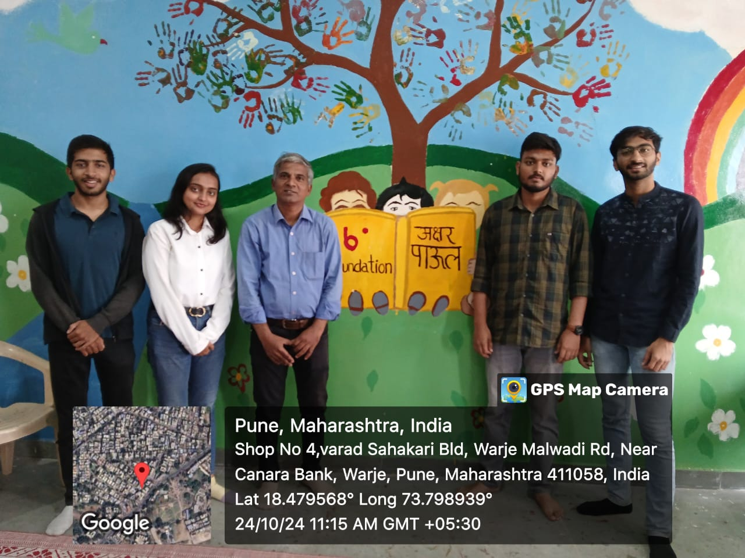



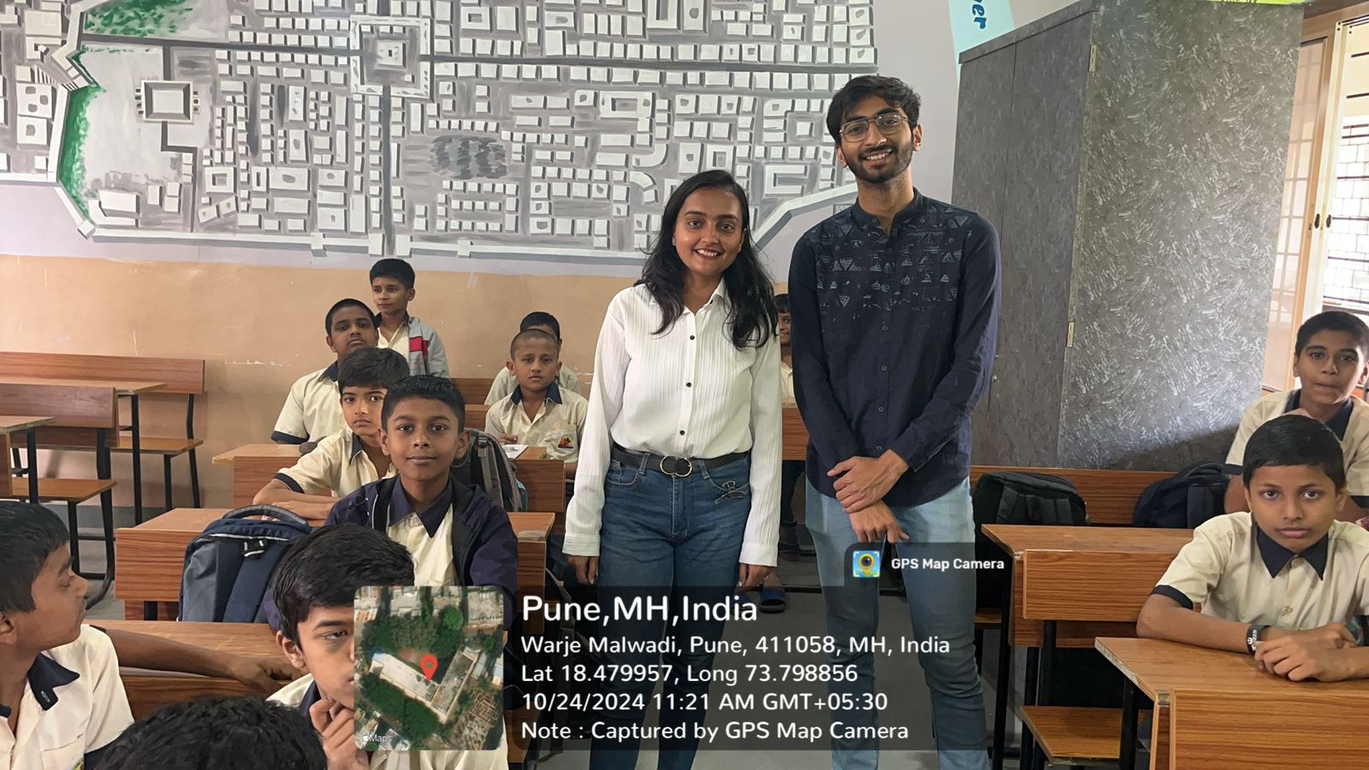



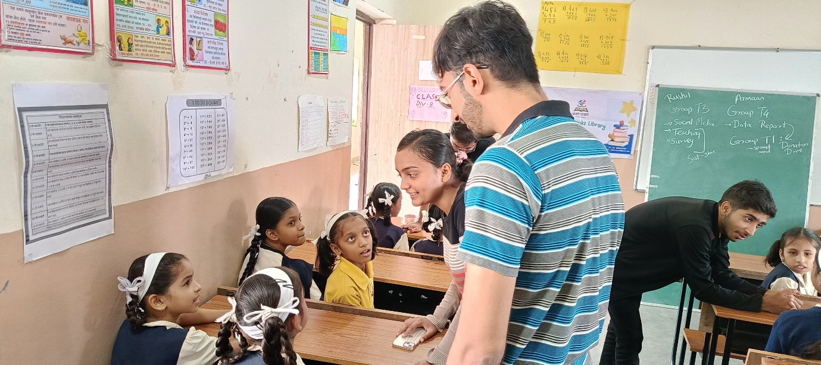

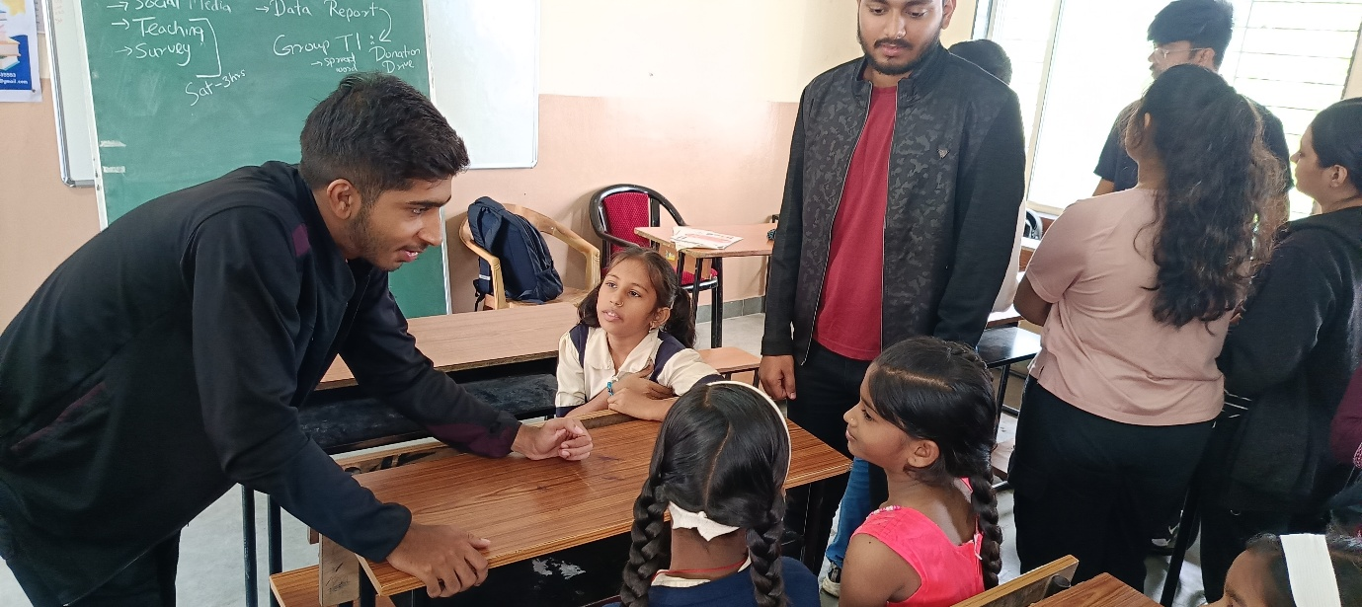

**12. FINAL APPLICATION**

**WEBSITE**

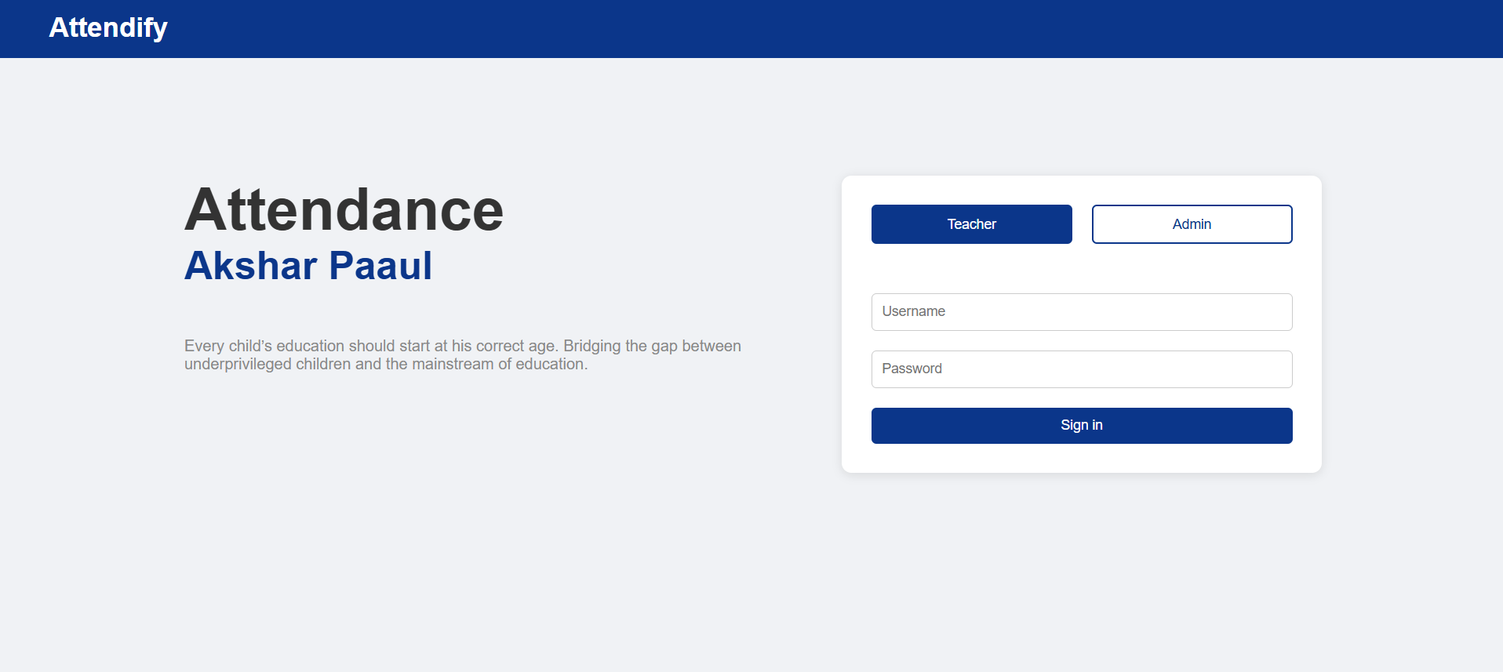

***Login Page***

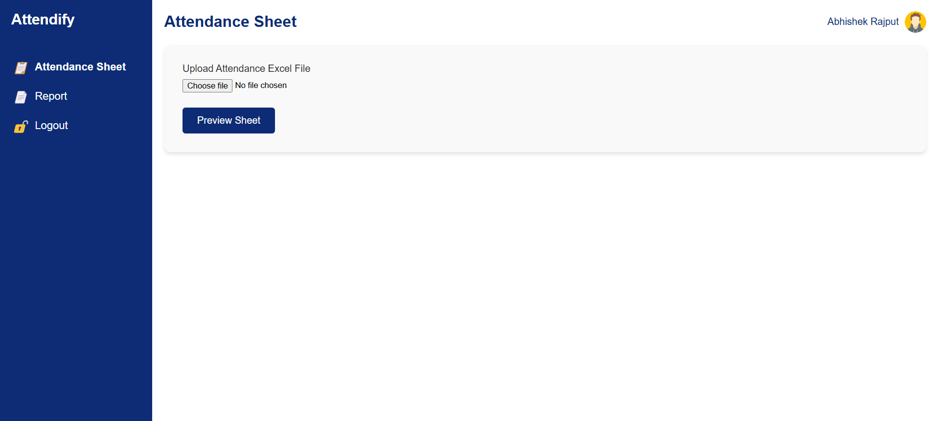

***Attendance Sheet Page***

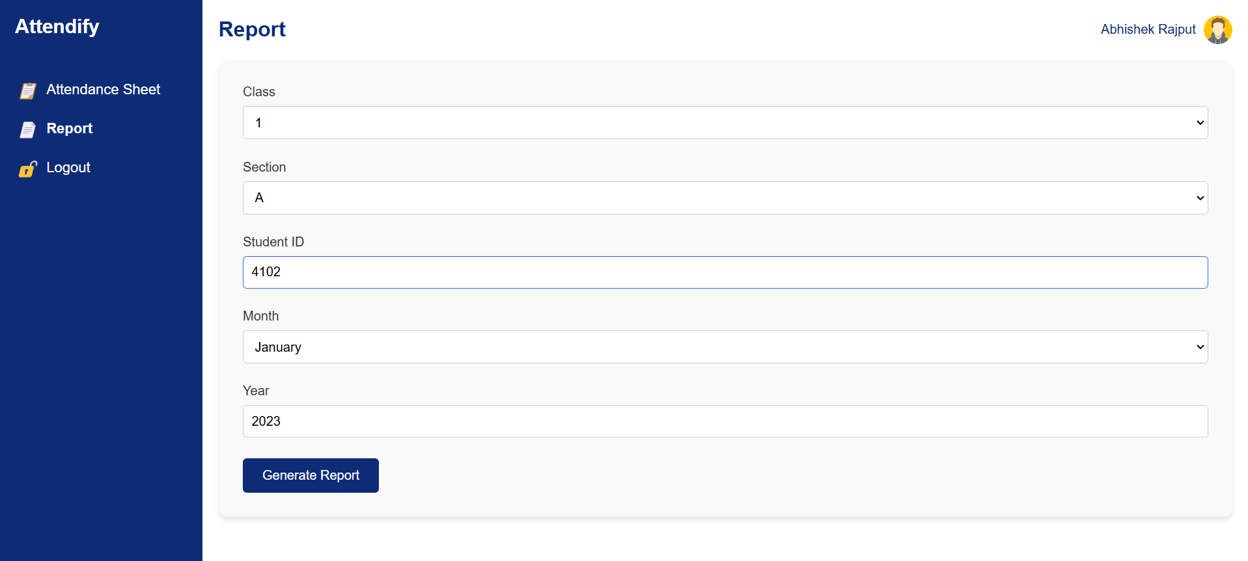

***Report Generation Page***

**POWERBI**

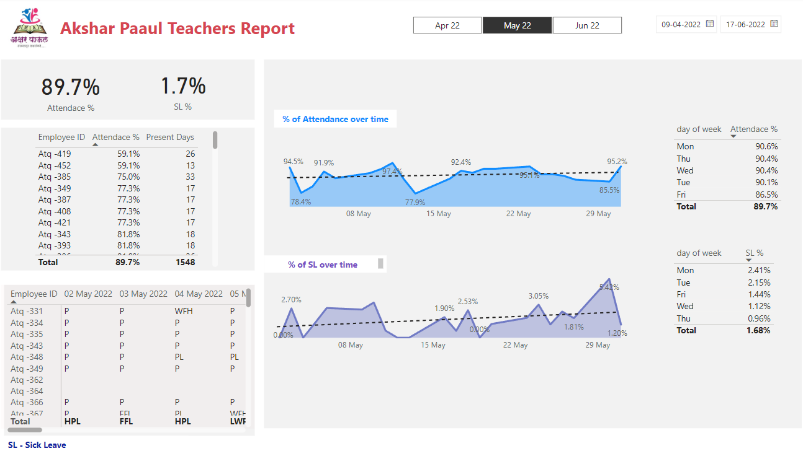

***PowerBI Report***

**14. CONCLUSION**

The NGO's developed biometric attendance management system offers an effective, precise, and user-friendly solution for monitoring and handling attendance records. By digitizing and standardizing attendance records, the system gets rid of the manual record-keeping process, which decreases the possibility of mistakes and saves time. The process of design involved building a thorough database in MySQL, creating a user-friendly interface, and producing informative reports with Power BI, all of which enhance the overall experience.

Despite facing challenges such as changing requirements and intricate integration, the project overcame these hurdles through flexible planning and rigorous testing methods. The ultimate iteration of the system is adaptable and can be expanded as the NGO's requirements increase. This project addresses current attendance management needs and lays the groundwork for potential future growth, like integrating advanced analytics or linking with other organizational systems.

To sum up, the biometric attendance system shows a major boost in efficiency for the NGO due to effective use of data management and software development principles. It shows how technology can be utilized to assist organizational objectives, guaranteeing an efficient method for monitoring attendance and managing data.